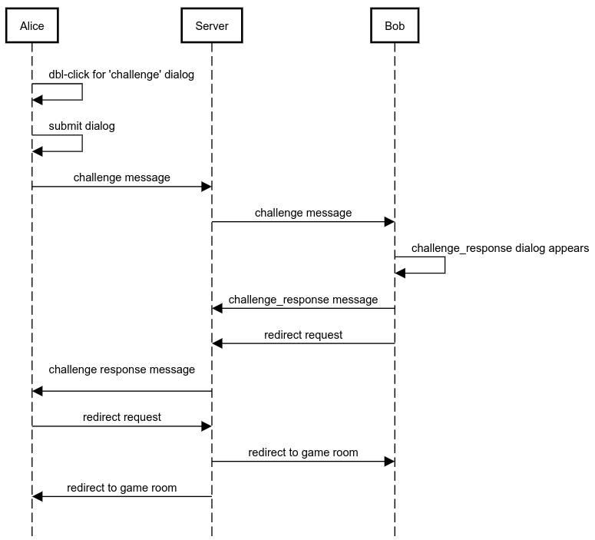Illustration 1: Challenge Sequence Diagram

